A Retrieval-Augmented Question Answering System for Cricket Rules
Ronik Karki, Kalam Uddin, Nischal Subedi
Tagliatela College of Engineering, University of New Haven
Abstract
We build a retrieval-augmented generation (RAG) question answering system for answering domain-specific questions about ODI cricket playing rules. The system extracts texts from the official ICC playing-condition document, stores chunked passages in vector database, and retrieves relevant context at query with three Large Language Models (LLMs): Llama 3.2, Phi-3 and Mistral.
We evaluate these models on a set of 14 questions based on rule definitions, penalties and procedures. We compare the models with response quality, accuracy, reasoning and consistency. Based on our findings, models benefit from retrieval, but the behavior of the models differs: Phi-3 gives short and safe answers, Llama 3.2 gives more complete explanations, and Mistral is more verbose but less precise.

Introduction
Large Language Model (LLM) is a language model which is trained with text datasets and is used for natural language processing tasks like text translation and generation. For Question answering over highly technical document task, LLMs often struggle because the information is scattered across many sections which contains long clauses, exceptions, and specific cases. When queried without context, models often hallucinate or generalizes from unrelated content. Retrieval-Augmented Generation (RAG) reduces these problems by grounding the answer in retrieved passages (Patrick Lewis 2021). Retrieval-Augmented Generation (RAG) is an AI technique that enhances Large Language Models (LLMs) by combining them with an external data source which allows LLMs to provide more accurate results. It retrieves only relevant text from the source document and provides it to the model as context. This helps model to reduce hallucinations and generate more accurate answers. Research has shown that RAG improves factual accuracy in many tasks such as summarization, domain-specific reasoning and open-domain question answering (Mojtaba Komeili 2021).
In this project, we have built a small RAG pipeline for answering questions about official cricket rulebook. We have used RAG setup to evaluate three different LLMs on how well different language models handle this task. We chose cricket rulebook because of its complex and technicality which requires precise interpretation, a small misunderstanding can change the rule. Cricket rules have many exceptions, special condition and steps which makes a strong test evaluation for RAG system.
Our goal is to build a small but complex RAG system that processes the rulebook document, stores the information in searchable format, retrieves the most relevant text for user questions and generates the closest answer to the rule. We compared three LLMs- Llama 3.2, Phi-3 and Mistral, how these models behave under same setup. We analyze the model’s accuracy and clarity of the answers; on how much they relied on the retrieved text and where they make mistake.
This study gives a practical insight of how different LLMs perform in domain-specific setting. It also shows how retrieval can help to stabilize the quality of the answer and reduce chance of mislead. The project is available at project link.

System Overview
Our RAG system follows a standard pipeline by earlier work on retrieval-based language modeling: Document Processing, Embedding & Vector store, Retrieval, LLM answer generation and Evaluation (Gautier Izacard 2021). The system is designed to answer questions about official cricket rules.

Architecture Implementation

Preprocessing
The primary source is the Laws of Cricket. This rulebook is long, complex and covers many cases, so preprocessing must be done in suitable format for retrieval. The document is divided into smaller chunks by using simple sliding-window method with overlapping to maintain context between the chunks. Total number of tokens is 1200 per chunks with 100 tokens overlapping to maintain context continuity. This ensures relevant part to be retrieved efficiently.
  - Embedding & Vector Store
Each chunk is then converted into a numeric embedding using all-MiniLM via Ollama which captures the semantic meaning of each chunk. All vectors are stored in a vector database “ChromaDB” for similarity search.
When the user submits a question, the query is also converted to embedding the same way. The system finds and retrieves the most relevant chunk using cosine similarity. Cosine similarity measures how alike two vector embeddings are. This ensures that the model only reads the part of the document that matches the question.
  - Retrieval
The System uses a standard similarity-based retrieval method. The query embedded vector is compared to all stored rulebook chunk vector using cosine similarity. This measures how close the meaning of the question is to the meaning of each chunk.
We select the top k=3 most similar chunks. Using three chunks gives enough context while keeping the prompt short. This also reduces the chance of returning unrelated text.
After retrieval, the system builds a prompt that includes the question and retrieved chunks. We use a simple instruction stating only to use the context, don’t invent new rules and answer briefly and state relevant law number. This instruction forces the model to rely only on the retrieved text instead of making up answers. This kind of instruction prompt has shown to lower hallucinates rates in retrieval-augmented systems (Kurt Shuster 2021).

LLMs Evaluated
The system is tested with three different LLMs- Llama 3.2, Phi-3 and Mistral to compare their performance. Each model is set up in the same RAG interface and ran locally via Ollama, so the evaluation remains fair. All models use the same retrieval results, chunk sizes and prompt style.
- Llama 3.2
  - Family: Meta Llama
  - Strength: reasoning, structed answers
- Phi-3
  - Family: Microsoft Phi
  - Strength: concise, safe grounding
- Mistral
  - Family: Mistral 7B
  - Strength: fluent, detailed wording

Evaluation Metric
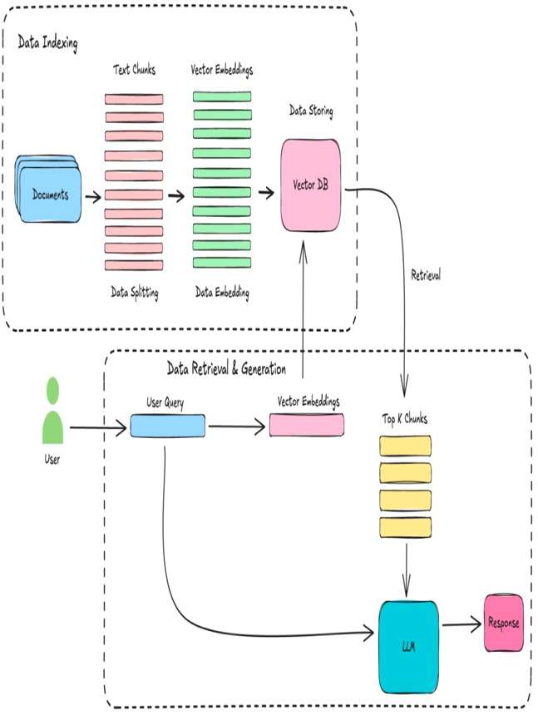
Figure 1: This figure shows the architecture of our system. The figure is divided into Data Indexing and Data Retrieval & Generation. Data Indexing consist of Preprocessing, Vector Embedding & Storage. Data Retrieval & Generation part shows how user query is converted to vector embedding to retrieve chunks and LLM to give the final response
We compute semantic similarity between the model’s answer and the retrieved context using all-MiniLM-L6-V2 embedding (Nils Reimers 2019). The models have been evaluated based on accuracy, faithfulness, hallucination levels and agreement with the gold answers. All scores are then computed using the sentence embedding to measure the semantic similarity between the two texts.
- Accuracy: Accuracy measures how close the model is to the gold answer. It is computed by cosine similarity between model answer and reference answer. Higher score meaning the model captured meaning of correct rule closely.
- Faithfulness: Faithfulness measures how well the answer matches the retrieved context. Same similarity method is used for this as well, but this time we compare the answer to the three retrieved chunks. Higher faithfulness score means the model stayed grounded in the retrieved text instead of adding unrelated context.
- Hallucination Level: Hallucination is derived from the faithfulness score. If the answer does not align well with the retrieved context, it is marked with hallucination. We use three ranges:
  - Faithfulness >_ 0.70 = Low Hallucination
  - Faithfulness >_0.50 = Medium Hallucination
  - Faithfulness < 0.50 = High hallucination
This gives a clear view of when model stays within the rules or when it drifts away from the facts.
- Agreement with Gold Answers: Gold answers are manually written reference answer for each question. It gives direct meaning of the rulebook. The accuracy metric measures the similarity to these gold answers. We also manually check whether the model picks the correct law to confirm that the similarity score truly reflects the correct meaning.
- Domain Specific Question Set
We included 14 questions covering definitions, penalties, and in-match procedures for the model.
- What is a no-ball?
- What is a boundary six in cricket?
- What is the powerplay in ODI cricket?
- What does LBW stand for?
- How many players constitute the playing eleven in an ODI match for each side according to ICC standard ODI playing conditions
- What is the maximum number of substitute fielders a team may nominate in addition to their playing eleven before the toss?
- Can a player from the starting eleven be replaced after the toss without consent of the opposing captain?
- If a substitute fielder is used, under what condition(s) must the substitute have been nominated before the match?
- According to standard ODI playing conditions, which official(s) must verify the nominated playing eleven and substitutes immediately prior to the toss?
- Is the use of the standard Laws of Cricket retained in ODI matches under ICC playing conditions, except where modified by the ODI Playing Conditions document?
- Under the standard ODI playing conditions, what happens if a player is absent from the field for longer than 8 minutes during a session of play?
- According to ODI playing conditions, who has the authority to allow a suspended player or support personnel to act as a substitute fielder during a match?
- Does the substitute-fewer rule allow any player not named on the original nomination list to field as a substitute under normal circumstances?
- What happens to a substitute fielder’s eligibility if he or she has been suspended from participation in the match from the toss onward
Gold Answers are also created for these questions directly from the rulebook.
- LLM Implementation
All models are run locally through Ollama, using the same retrieval pipeline, same prompt template and no fine tuning. Each model receives the same input: the user question and the top 3 retrieved chunk from the document.
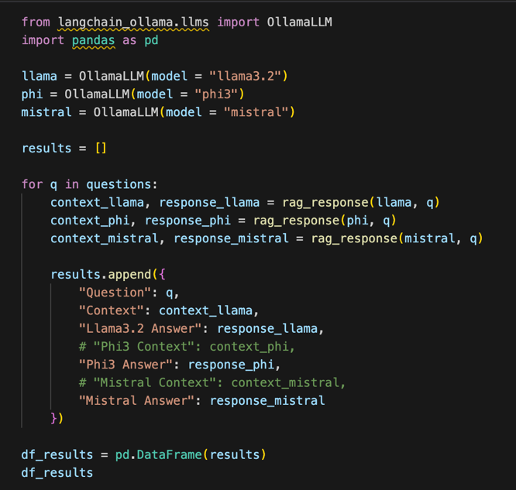
Figure 2: This figure shows the code block of the RAG pipeline for all three models.
- Needed libraries are imported
- Three models are loaded.
- List is created to store outputs
- Loop is created for the questions
- Rag pipeline is run for each model
- Results is saved as dictionary
- Results is converted to dataframe

Llama 3.2
The first model is Llama 3.2. It is loaded using
llama = ollamaLLM(model=”llama3.2”).
- Decoder-only transformer architecture
- Runs with default ollama generation setting
- Called through llama.invoke(prompt) inside the RAG function
- Takes the retrieved chunks and produces a short answer
  - Phi-3
The second model is Phi-3. It is loaded using
Phi = ollamaLLM(model=”phi3”).
- Lightweight transformer optimized for efficiency
- Default Ollama setup
  - Mistral
The third model is Mistral. It is loaded as
Mistral=ollamaLLM(model=”mistral”).
- Transformer model with sliding-window attention
- Same setup with prompt, retrieved context and evaluation step

No fine tuning has been done for any of the models.
- Comparative Analysis of the Models
The three models are compared based on accuracy and faithfulness which is computed by cosine similarity.
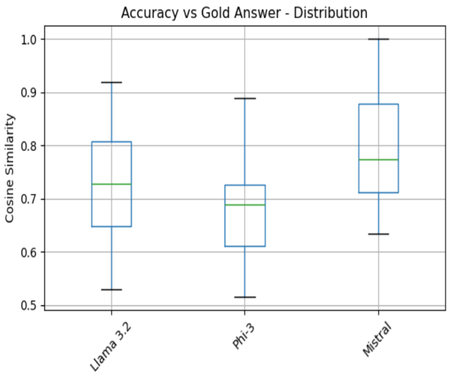
Figure 3: Cosine Similarity of LLMs

The graph shows the cosine similarity between each model’s answer to the gold answer. Higher values mean the answer is closer to the correct one.
- Llama 3.2
  - Median score is around 0.73
  - This proves Llama is stable and consistently accurate but has few low scoring cases
- Phi-3
  - Median score is around 0.69
  - This shows Phi-3 is steady but stays in mid-range accuracy band
- Mistral
  - Median score is around 0.77
  - This shows Mistral gives the most accurate answer but has a wider spread

Accuracy
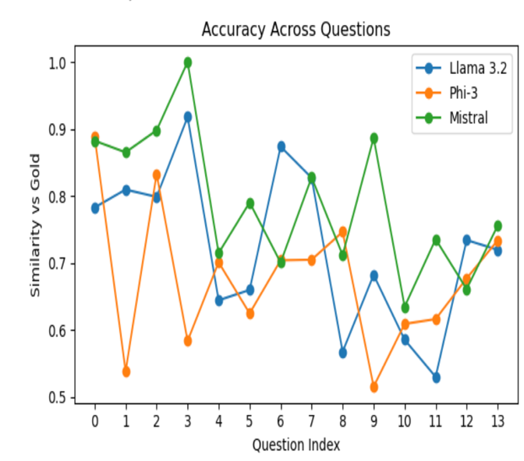
Figure 4: Accuracy across Questions

This graph shows how each model performs question by question, using cosine similarity against the gold answer. It shows how accuracy varies a lot from question to question. No model is perfect on all question.
- Llama 3.2
  - Strong on several questions
  - Noticeable performance drop and rise
  - Good accuracy but less consistent
- Phi-3
  - Lowest scores on many question
  - Highest volatility but sensitive to question difficulty
- Mistral
  - Most stable high score across
  - Most reliable and best average accuracy

Figure 5: Model Accuracy
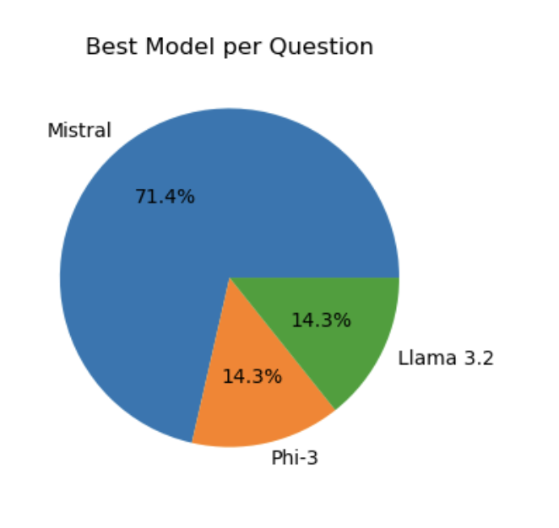
The pie chart shows how often each model produce the most accurate answer.
- Llama 3.2 – 14.3%
  - Does well on some questions but not consistent
- Phi-3 – 14.3%
  - Like Llama, it only performs well on some questions but struggles often
- Mistral – 71.4%
  - Top performing with consistent output closest to the gold answer
  - Faithfulness
Faithfulness measures whether the model stays grounded in the retrieved text and avoids adding new unrelated text.
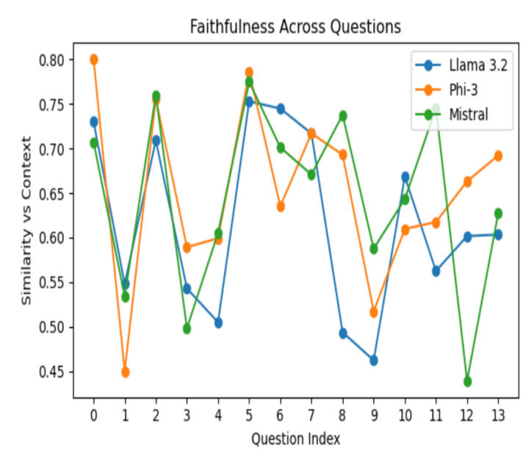
Figure 6: Faithfulness across Questions

This graph shows how close model answer matches with retrieved context for each question. Higher meaning model stays close to gold answer rather than adding extra information.
- Llama 3.2
  - Most fluctuate
  - Inconsistent faithfulness; sometimes strong, sometimes weak
- Phi-3
  - Highest faithfulness on many questions but lowest also
  - Model sticks to context when it understands but drops sharply when it doesn’t
- Mistral
  - Stays in mid to high range
  - Balanced and reliable
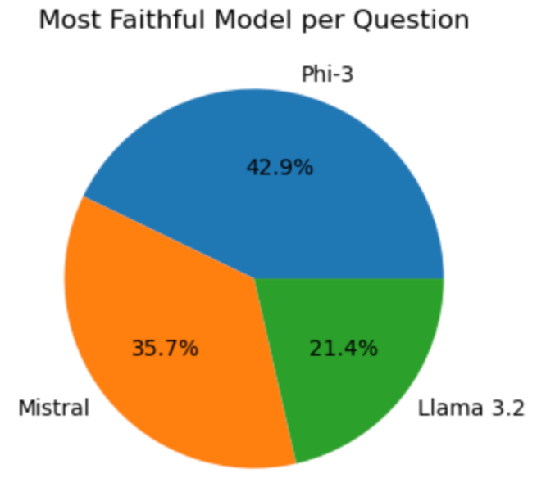
Figure 7: Model Faithfulness

This pie chart shows how often each model stayed close to the retrieved context.
- Llama 3.2 – 21.4%
  - Most faithful on 3 out of 14 questions
  - Faithful on simple context but hallucinates on difficult ones
- Phi-3 – 42.9%
  - Most faithful on 6 out of 14 questions
  - Most faithful on most question
- Mistral – 35.7%
  - Most faithful on 5 out of 14 questions
  - Steady faithfulness
- Strength and Weakness of Models

Llama-3.2
Strength
- Gives clear and well-structed answers
- Good accuracy when question matches the retrieved text
- Handles multi step rules better than other two models
Weakness
- Faithfulness is inconsistent
- More likely to add extra texts
- Performance drops when retrieval is slightly off

Phi-3
Strength
- Most faithful to retrieved context across questions
- Usually avoids adding unsupported details
- Good at short, factual answers
Weakness
- Mixed accuracy – some answers matches the context but misses key parts
- More sensitive to retrieval quality
- Sometimes gives short and incomplete answers

Mistral
Strength
- Most consistent across accuracy and faithfulness
- Handles all varieties of questions well
- Often retrieves correct idea even when context is long or technical
Weakness
- Too general- sometimes summarizes instead of quoting rule precisely
- Can miss condition or exceptions in rules
- Faithfulness dips on dense text

Limitations
This study has several limitations. The evaluation is based on small set of questions, so the results cannot represent the full complexity. Our RAG system uses a simple retrieval setup with basic chunking and similarity search. More advanced setup might lead to different result. The evaluation only relies on cosine similarity so the scoring may miss some correctness issue.

Conclusion
In this project, we built a small RAG system and tested three LLMs- Llama 3.2, Phi-3 and Mistral to handle question answering over cricket rule. The results shows that RAG improves stability, but each model behaves differently. Mistral gives most accurate answer, Phi-3 is most faithful, and Llama-3.2 is the least consistent. These differences highlight how model size, training data and reasoning style affects performance of model. Overall, the study shows that even a simple RAG system can reduce errors and help models follow rulebook, but more complex design and evaluation are needed for high precise documents.

References
Gautier Izacard, Edouard Grave. 2021. ACL Anthology. 04. Accessed 12 2025. https://aclanthology.org/2021.eacl-main.74/.
Kurt Shuster, Spencer Poff, Moya Chen, Douwe Kiela, Jason Weston. 2021. ACL Anthology. 11. Accessed 12 2025. https://aclanthology.org/2021.findings-emnlp.320/.
Mojtaba Komeili, Kurt Shuster, Jason Weston. 2021. arXiv. 07 21. Accessed 12 2025. https://arxiv.org/abs/2107.07566.
Nils Reimers, Iryna Gurevych. 2019. arXiv. 08. Accessed 12 2025. https://arxiv.org/abs/1908.10084.
Patrick Lewis, Ethan Perez, Aleksandra Piktus, Fabio Petroni, Vladimir Karpukhin, Naman Goyal, Heinrich Küttler, Mike Lewis, Wen-tau Yih, Tim Rocktäschel, Sebastian Riedel, Douwe Kiela. 2021. arXiv. 04 12. Accessed 12 05, 2025. https://arxiv.org/pdf/2005.11401.

